|  |
| --- |
| CREATING NEW USER LINKS |

Cobalt is not constrained by the User Links that it created as part of the project generation process. As projects demand customization options, there will be a need for new pages, which in turn will require new User Links.

**CREATE A NEW PAGE**

For the purposes of demonstration we will duplicate the “View Character” module and replicate it as a “different” page. Inside your project folder (/rpg_char_system), navigate to /modules/character and create a copy of listview_character.php. Name it “listview_character_again.php”

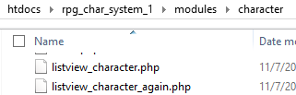

In your favorite IDE, open listview_character_again.php. We will tweak the privilege requirement for this page to be different from listview_character.php to demonstrate the creation of a new User Link. On line 9, change the value inside init_cobalt() from “View character” to “View character again”. This is case-sensitive, so remember what you type in.

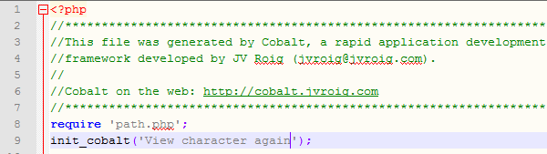

**CREATE A NEW USER LINK**

Back to the system, navigate to the “User Links” page and click “Add new record”. You will need to provide information for the new User Link to work. The most important piece of information to note is the “Name” field, which must correspond to the value we changed a while ago in the init_cobalt() function.

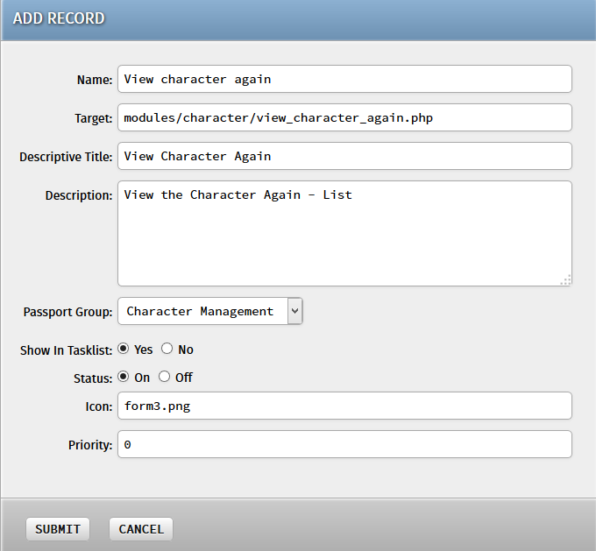

Hit “Submit” and the new User Link will be added into the roster of modules the system can navigate on.



**ENABLE THE NEW USER LINK TO USERS**

Simply creating the new User Link is not enough for it to be accessible in the system. We still need to let the users access this new User Link. Back to the “User Roles” page, click on the “Role Permissions” link once more for the “Player” User Role. You should now see the “View Character Again” module at the very bottom of the list.

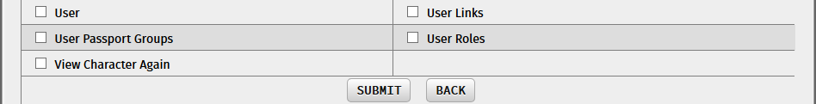

Tick the checkbox corresponding to that module and hit “Submit”. Now the User Role has the privilege for that User Link. The process is only half-complete, however, because we still need to “Cascade” the changes made to all the users with that User Role. This can be done by the other operation in the User Roles list – the “Cascade Update” operation.



The “Role Cascade Update” module will update all the users with that User Role to have the new set of privileges under that User Role. Ordinarily this can take a while if there are a huge number of users, but for our case it should not take long. Simply click the “Cascade Update” button to begin the operation.

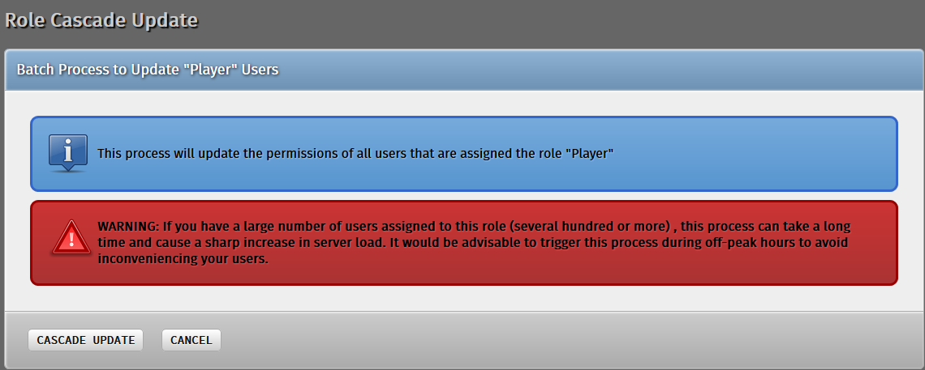

If you had changed the user’s privileges via the “Set User Passports” module in the previous tutorial, then you may encounter this page, which means that the custom user earlier had been removed from the “Player” User Role because his privileges had been customized.

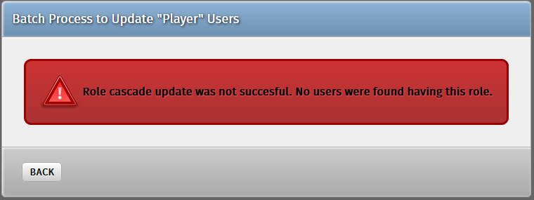

Should this happen, simply re-assign the user back to the “Player” User Role and perform the “Cascade Update” operation once again.

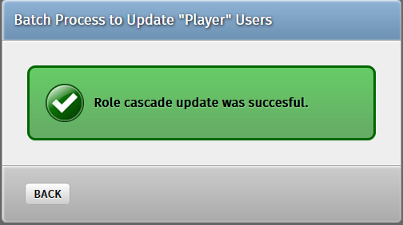

Once successful, our custom user should now be able to browse the new page!

